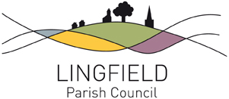
LINGFIELD PARISH COUNCIL
Parish Clerk: Emma Fulham

clerk@lingfieldparishcouncil.gov.uk

01342 835557

11th March 2026

TWENTY SIXTH ANNUAL PARISH ASSEMBLY WEDNESDAY 25th MARCH 2026 7:30pm

LINGFIELD AND DORMANSLAND COMMUNITY CENTRE

A G E N D A

- Introduction and Welcome by the Chair of the Parish Council – Cllr Cath Hearnden
- Report from the Chair of the Parish Council – Cllr Cath Hearnden
- Presentations from Catherine Dainkeh on TDC project refurbishment and Robert Mitchell Lingfield Cricket Club.
- Public Questions and Discussion

Cath Hearnden
Chair of Lingfield Parish Council

Drinks and nibbles are available to all attendees – everyone welcome !

