

THERE WILL BE A MEETING OF THE PLANNING COMMITTEE OF LINGFIELD PARISH COUNCIL TO BE HELD AT LINGFIELD AND DORMANSLAND COMMUNITY CENTRE ON WEDNESDAY 29th MARCH 2023 AT 7 PM
MEMBERS OF THE PUBLIC ARE WELCOME TO ATTEND

AGENDA

- To record apologies for absence
- To sign as a correct record minutes of the meeting held on 15th March 2023
- To note any matters arising from previous minutes
- To note any declarations of interest
- To consider planning applications received since the last meeting:-

Application | Description | Address
2023/130 | Demolition of existing buildings and erection of a detached dwelling | Land at Star Cottages, Lingfield, RH7 6AH
2023/267/N | Erection of a timber construction storage building on an existing concrete slab (Notification of Agricultural Permitted Development) | Kingsley Farm, Blackberry Road, Felcourt, RH7 6NQ
2023/295 | Demolition of existing conservatory. Erection of single storey side extension with rendered finish, pitched roof with two roof lights and rear fenestration. | Avondale, Newchapel Road, Lingfield RH7 6BJ
2023/296 | Erection of a two storey side extension and internal alteration | Soft Meadows, Crowhurst Road, Lingfield RH7 6DA

- To note any results since the last meeting

Application No | Address | Description | PC Comment | Decision
2022/529 | The Oast House, Rowlands Farm, Newchapel Road, Lingfield, Surrey, RH7 6BJ | Replacement outbuilding and new shed | No objection | Refused

- To note any appeals received
- Matters for reporting or inclusion on future agenda
- Date of next meeting - 12th April 2023

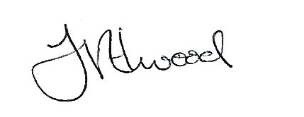

Mrs Fay Elwood, Parish Clerk, 23rd March 2023

