___________________________________________________________________________

Dear Committee Member 9th February 2023

You are invited to a meeting of LINGFIELD PARISH COUNCIL ‘FRIENDS OF LINGFIELD POND’ COMMITTEE on WEDNESDAY 15th FEBRUARY at 6.30pm to be held at Lingfield and Dormansland Community Centre

MEMBERS OF THE PUBLIC ARE WELCOME TO ATTEND
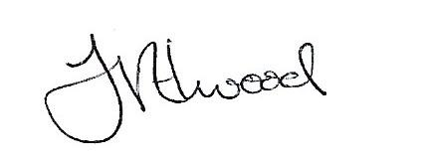
Mrs Fay Elwood
Clerk to Lingfield Parish Council

A G E N D A

- Apologies for absence

- Declarations of Interest

- Minutes of meeting held on 9th November 2022

- Water Quality

- Planting

- Any other business

- Date of next meeting

Committee membership:-
Roger Ohlson
Jason Fudge
Clive Jecks
Rita Russell

