___________________________________________________________________________

Dear Committee Member 20th July 2022

You are invited to a meeting of LINGFIELD PARISH COUNCIL ‘FRIENDS OF LINGFIELD POND’ COMMITTEE on TUESDAY 26th July 2022 at 6.30pm to be held at Lingfield and Dormansland Community Centre

MEMBERS OF THE PUBLIC ARE WELCOME TO ATTEND
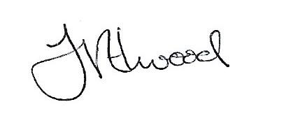
Mrs Fay Elwood
Clerk to Lingfield Parish Council

A G E N D A

- Apologies for absence

- Declarations of Interest

- Committee membership

- Water quality

- Memorial benches

- Signage

- Any other business

- Date of next meeting

Committee membership:-
Clive Jecks
Jason Fudge
Roger Ohlson
Rita Russell

