___________________________________________________________________________

Dear Committee Member 8th October 2021

You are invited to a meeting of LINGFIELD PARISH COUNCIL ‘FRIENDS OF LINGFIELD POND’ COMMITTEE on WEDNESDAY13TH OCTOBER 2021 at 7.30pm to be held at Lingfield and Dormansland Community Centre

MEMBERS OF THE PUBLIC ARE WELCOME TO ATTEND
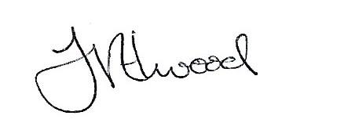
Mrs Fay Elwood
Clerk to Lingfield Parish Council

A G E N D A

- Apologies for absence

- Declarations of Interest

- To identity work still to be carried out at Gun Pond

- To agree memorial bench policy

- To discuss planting schemes

- To consider any known requirements for parish council funding

- To report on water quality and pest control

- To report progress on signage

- Any other business

- Date of next meeting

Committee membership:-
Clive Jecks Jason Fudge
Andrea Watson Roger Ohlson
Ian Tomsett Rita Russell

