___________________________________________________________________________

Dear Committee Member 3rd February 2022

You are invited to a meeting of LINGFIELD PARISH COUNCIL ‘FRIENDS OF LINGFIELD POND’ COMMITTEE on WEDNESDAY 9th FEBRUARY 2022 at 7.30pm to be held at Lingfield and Dormansland Community Centre

MEMBERS OF THE PUBLIC ARE WELCOME TO ATTEND
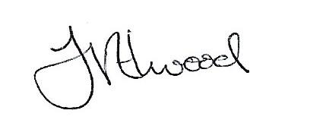
Mrs Fay Elwood
Clerk to Lingfield Parish Council

A G E N D A

- Apologies for absence

- Declarations of Interest

- To approve the minutes of the last meeting as a true and accurate record

- To review the memorial bench policy and decide whether any amendments are required

- To discuss planting schemes

- To consider any known requirements for parish council funding

- To report on water quality and pest control

- To report progress on signage

- Any other business

- Date of next meeting – 13th April 2022

Committee membership:-
Clive Jecks Jason Fudge
Andrea Watson Roger Ohlson
Ian Tomsett Rita Russell

