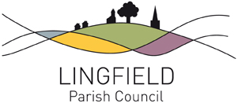

NOTICE OF CONCLUSION OF AUDIT
Annual Governance and Accountability Return for the year ended 31 March 2020
Sections 20(2) and 25 of the Local Audit and Accountability Act 2014
Accounts and Audit Regulations 2015 (SI 2015/234)
Accounts and Audit (Coronavirus) (Amendment) Regulations 2020 (SI 2020/404)

- The audit of accounts for Lingfield Parish Council for the year ended 31 March 2020 has been completed and the accounts have been published.

- The Annual Governance & Accountability Return is available for inspection by any local government elector of the area of Lingfield Parish Council on application to:

Mrs Fay Elwood
Clerk to Lingfield Parish Council
Lingfield and Dormansland Community Centre
High Street, Lingfield RH7 6QL
Tel: 01342 835557
Email: lingfieldpc@gmail.com

Inspection rights may be exercised between 10am and 2pm on Monday to Thursday.

- Copies will be provided to any person on payment of £2 for each copy of the Annual Governance and Accountability Return.

Announcement made by: Mrs Fay Elwood
On: 2nd September 2020

